20MCA136 – NETWORKING & SYSTEM ADMINISTRATION LAB Dept. of Computer Applications

NETWORKING & SYSTEM ADMINISTRATION LAB

Name: Vishnu Vijayakumar
Roll No: 53 Batch: B
Date: 12-05-2022

Experiment No.: 20

Aim
Write a shell script to find the average of the numbers entered in a command line.

Program
echo "Enter the limit"
read N
i=1 sum=0
echo "Enter 4 integers”
while [ $i -le $N ]
do
read num sum=$((sum + num)) i=$((i + 1))
done
avg=$(echo "scale=3; $sum / $N "| bc -l) echo "the average is"$avg

Output screenshot

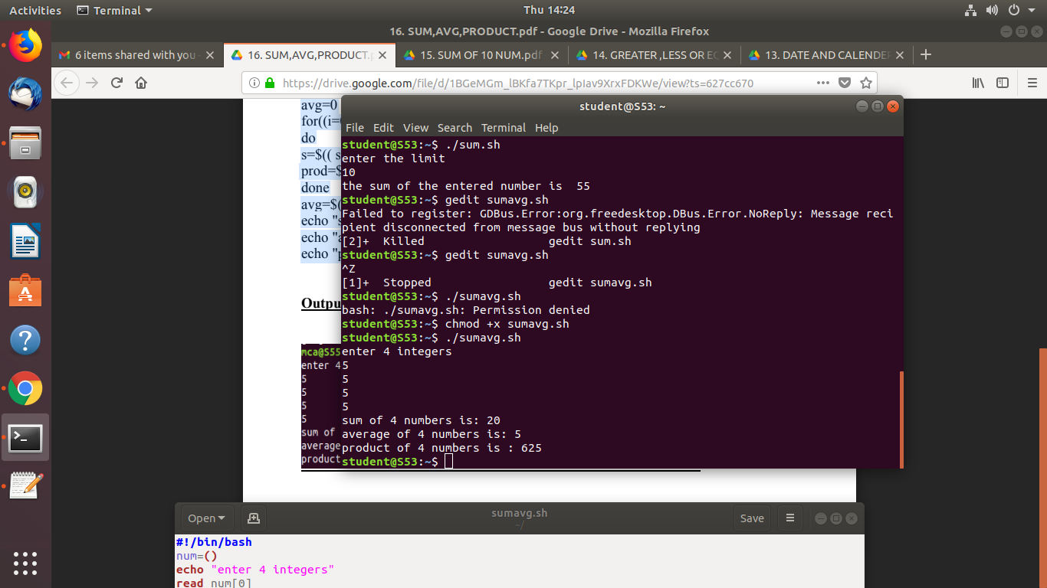

Amal Jyothi College of Engineering, Kanjirappally

